Nutrition in surgery
LECTURE No. 1

Introduction

- 30% of all patients with GIT diseases.
- 60% of patients with prolonged hospitalization due to postoperative complications.
- Its frequently unrecognized and makes the patient more prone to postoperative problems.
- The aim of nutritional support is to:
- Identify those patients in need of nutritional support in a timely manner.
- Ensure that their nutritional requirements are met by the most appropriate route and manner to minimize the risk of complications.

Physiological facts

Short fast (<12 hours)
- The majority of the food ingested in previous meals has been utilized.
- Plasma insulin levels fall.
- Plasma glucagon levels rise.
- Conversion of the hepatic glycogen (which is about 200 g) into glucose.
- Skeletal muscles glycogen (which is about 500 g) cannot utilized directly, instead, it is broken down (Glycogenolysis) and converted to lactate that exported to the liver to become glucose by Cori cycle.

Longer fast (24 hours or more)
- Body stores of glycogen are depleted.
- de novo glucose production occurs primarily in the liver (Gluconeogensis), utilizing amino acids (especially glutamine and alanine) derived from the catabolism of skeletal muscle protein.

More prolonged fasting
- Breakdown of fat stores provides Glycerol that can be converted:
- Glucose
- Fatty acids: in the liver, it’ll be converted to ketone bodies which can be used as a fuel by almost all of body's tissues.
- This conversion to a ‘fat fuel economy’ reduces the need for muscle breakdown.
- With prolonged starvation, there is a significant reduction in the resting energy expenditure from 25-30 kcal/kg/day to 15-20 kcal/kg/day.

Nutritional assessment
- Severe malnutrition can be easily diagnosed as the patient has muscle wasting of proximal limbs and temporalis muscle, pressure sores and apathy.
- Milder degree of nutritional impairment is frequently overlooked.
There are three groups of techniques available for nutritional assessments which are:

1. Body weight and anthropometric techniques
√ Body weight: we should notice that:
- It is unreliable indicator of nutritional status in critically ill patients (fluid retention).
- It can be compared with:
- Ideal body weight (from tables).
- Premorbid weight.
- Unintentional weight loss of > 10% of the patient's weight in the preceding 6 months is a prognostic indicator of poor clinical outcome.
- Body weight is usually corrected for height, in what is called (BMI) "Body Mass Index"

BMI $=\frac{weight\left(kg\right)}{{height(m)}^{2}}$
BMI < 18.5 indicates nutritional impairment.
BMI < 15 usually associates with significant hospital mortality.
√ Anthropometric techniques: include
- Triceps skin fold thickness
- Mid-arm muscle circumference
- Bioelectrical Impedance Analysis (BIA) for estimation of intra and extracellular fluid volumes.
They measure body fat and muscle mass (energy and protein stores), and they are unreliable if there is significant edema.

2. Clinical:
These depend on relating history and clinical signs to produce a "subjective global assessment" of the nutritional status.
√ History taken from the patient regarding:
- Weight change
- Dietary intake
- GIT symptoms
- Functional impairment
√ Physical signs:
- Muscular wasting
- Loss of subcutaneous fat
- Oedema
- Alopecia
- Others e.g., hand-grip strength.

3. Laboratory techniques:
√ Serum proteins: e.g., albumin, prealbumin, transferrin & retinol-binding protein.
- S. albumin may be used as screening tool for malnutrition, but its fall rapidly during inflammatory process.
- S. albumin of < 30 gL⁻¹ is an indicator of poor prognosis in surgical patients.
√ Lymphocytes count & skin testing for delayed hypersensitivity reaction: usually abnormal in malnutrition, due to defective immune function.

Recent Advances

(MUST) = Malnutrition Universal Screening Tool
Was introduced by the British Association of Parenteral and Enteral Nutrition
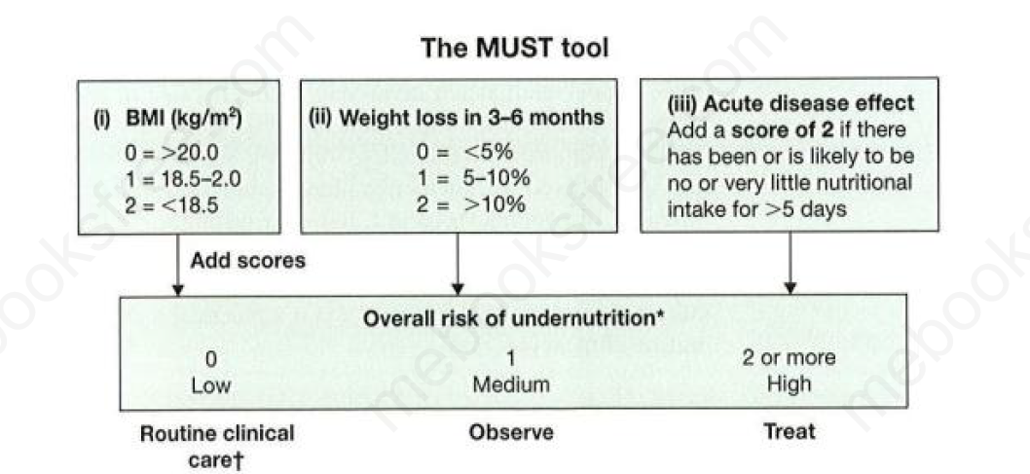

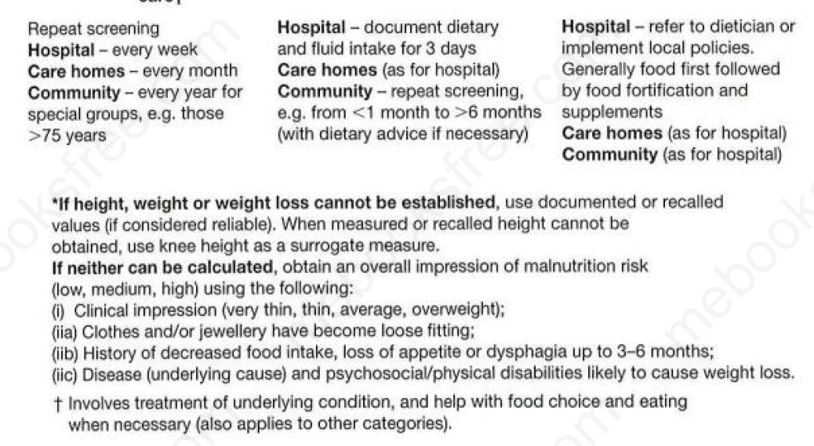

Nutritional requirements
Nutritional regimens should provide the patient with:
- Macronutrients, Protein, carbohydrates and lipids.
- Vitamins and trace elements.
- Electrolytes and water.
- Daily needs may change depending on patient’s condition.
- Overfeeding is the most common cause of complications (enteral or parenteral).
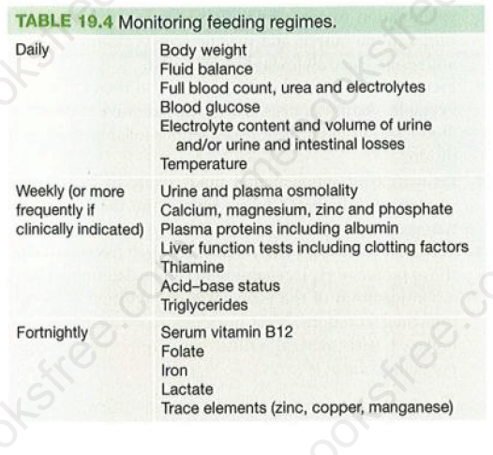

Short Bowel Syndrome
- When extensive loss of bowel length (<150 cm of remaining small intestine in adults) happens due to any cause (e.g., surgical resection) there will be many metabolic and nutritional consequences.
- Up to 50% of small bowel can be lost without permanent harmful effect.
- The clinical presentation is dependent upon the site and extent of intestinal resection.

Ileum
- It’s critical for fluid and electrolytes conservation.
- The only site for vitamin B12 and bile salts absorption.

Colon
- Water and salt absorption (efficiently absorbs 90%).
- Carbohydrate fermentation for production of medium chain fatty acids.

Effects of surgical bowel resection
- Resection of jejunum well tolerated.
- Resection of ilium:
- < 100 cm Steatorrhea needs oral Cholestyramine to bind bile salts.
- > 100 cm Dietary fat restriction and regular parenteral vitamin B12 supplement.
- > 200 cm The most challenging cases and may need parenteral fluid and nutritional supplements.

Complications
- Peptic Ulceration (Gastric hypersecretions)
- Gall stones (interruption of enterohepatic cycle of bile salts)
- Renal Stones (hyperoxaluria due to increase absorption of oxalate in the coon)
- Slurred speech and ataxia.

Treatment
- H2-receptor antagonist, reduce the amount of fluid secreted by the proximal GIT.
- Somatostatin analogue Octreotide, reduce the amount of fluid secreted by the proximal GIT and reduces GIT motility.
- Proton pump inhibitors, lowers gastric pH.
- Anti-motility drugs like Loperamide and Codeine phosphate.

